**Date: 23/10/2025**

**Name: Md. Moshiur Rahman**

**ID: 0242220005101871**

**Section: 63_M2**

**CSE416**

**Lab Performance: 02**

**Problem-01**

**Code:**

<!DOCTYPE html>

<html lang="en">

<!-- Write a program to find the factorial of a number. -->

<head>

<meta charset="UTF-8">

<meta name="viewport" content="width=device-width, initial-scale=1.0">

<title>Factorial of a Number</title>

</head>

<body>

<h2>Find Factorial</h2>

<input type="number" id="num1" placeholder="Enter a number">

<button onclick="findFactorial()">Find Factorial</button>

<p id="result1"></p>

<script>

function findFactorial() {

let n = parseInt(document.getElementById("num1").value);

let fact = 1;

for (let i = 1; i <= n; i++) {

fact *= i;

}

document.getElementById("result1").innerText = "Factorial of " + n + " = " + fact;

}

</script>

</body>

</html>

**Output:**

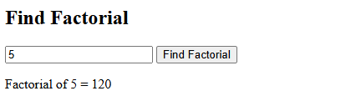

**Problem-02**

**Code:**

<!DOCTYPE html>

<html lang="en">

<!-- Write a program to find the largest among three numbers. -->

<head>

<meta charset="UTF-8">

<meta name="viewport" content="width=device-width, initial-scale=1.0">

<title>Largest Among Three Numbers</title>

</head>

<body>

<h2>Find Largest Number</h2>

<input type="number" id="a" placeholder="Enter first number">

<input type="number" id="b" placeholder="Enter second number">

<input type="number" id="c" placeholder="Enter third number">

<button onclick="findLargest()">Find Largest</button>

<p id="result2"></p>

<script>

function findLargest() {

let a = parseFloat(document.getElementById("a").value);

let b = parseFloat(document.getElementById("b").value);

let c = parseFloat(document.getElementById("c").value);

let largest;

if (a >= b && a >= c)

largest = a;

else if (b >= a && b >= c)

largest = b;

else

largest = c;

document.getElementById("result2").innerText = "Largest number is " + largest;

}

</script>

</body>

</html>

**Output:**

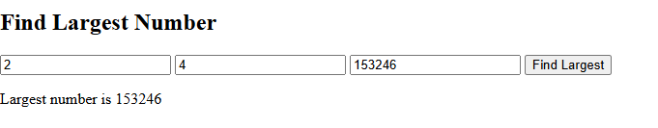

**Problem-03**

**Code:(HTML Code)**

<!DOCTYPE html>

<html lang="en">

<!-- Write a program to check whether a number is prime or not. -->

<head>

<meta charset="UTF-8">

<meta name="viewport" content="width=device-width, initial-scale=1.0">

<title>Prime Number Check</title>

</head>

<body>

<h2>Check Prime Number</h2>

<input type="number" id="num3" placeholder="Enter a number">

<button onclick="checkPrime()">Check</button>

<p id="result3"></p>

<script>

function checkPrime() {

let n = parseInt(document.getElementById("num3").value);

let isPrime = true;

if (n <= 1) isPrime = false;

else {

for (let i = 2; i <= n / 2; i++) {

if (n % i === 0) {

isPrime = false;

break;

}

}

}

document.getElementById("result3").innerText = isPrime ? n + " is Prime" : n + " is Not Prime";

}

</script>

</body>

</html>

**Output:**

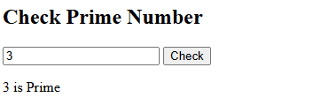

**Problem-04**

**Code:(HTML Code)**

<!DOCTYPE html>

<html lang="en">

<!-- Write a program to find the sum of all numbers from 1 to n. -->

<head>

<meta charset="UTF-8">

<meta name="viewport" content="width=device-width, initial-scale=1.0">

<title>Sum of Numbers from 1 to n</title>

</head>

<body>

<h2>Sum from 1 to n</h2>

<input type="number" id="num4" placeholder="Enter a number">

<button onclick="findSum()">Find Sum</button>

<p id="result4"></p>

<script>

function findSum() {

let n = parseInt(document.getElementById("num4").value);

let sum = 0;

for (let i = 1; i <= n; i++) {

sum += i;

}

document.getElementById("result4").innerText = "Sum from 1 to " + n + " = " + sum;

}

</script>

</body>

</html>

**Output:**

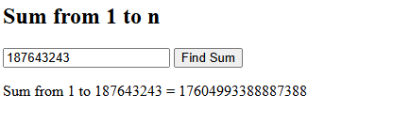

**Problem-05**

**Code:(HTML Code)**

<!DOCTYPE html>

<html lang="en">

<!-- Write a program to reverse a number (e.g., 123 → 321). -->

<head>

<meta charset="UTF-8">

<meta name="viewport" content="width=device-width, initial-scale=1.0">

<title>Reverse a Number</title>

</head>

<body>

<h2>Reverse a Number</h2>

<input type="number" id="num5" placeholder="Enter a number">

<button onclick="reverseNumber()">Reverse</button>

<p id="result5"></p>

<script>

function reverseNumber() {

let n = document.getElementById("num5").value;

let reversed = n.split('').reverse().join('');

document.getElementById("result5").innerText = "Reversed Number: " + reversed;

}

</script>

</body>

</html>

**Output:**

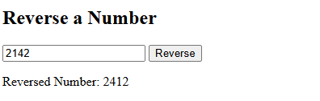

**Problem-06**

**Code:(HTML Code)**

<!DOCTYPE html>

<html lang="en">

<!-- Write a program to find the power of a number (without using Math.pow). -->

<head>

<meta charset="UTF-8">

<meta name="viewport" content="width=device-width, initial-scale=1.0">

<title>Power of a Number</title>

</head>

<body>

<h2>Find Power (a<sup>b</sup>)</h2>

<input type="number" id="base" placeholder="Enter base number">

<input type="number" id="exp" placeholder="Enter exponent">

<button onclick="findPower()">Calculate</button>

<p id="result6"></p>

<script>

function findPower() {

let base = parseFloat(document.getElementById("base").value);

let exp = parseInt(document.getElementById("exp").value);

let result = 1;

for (let i = 1; i <= exp; i++) {

result *= base;

}

document.getElementById("result6").innerText = base + " ^ " + exp + " = " + result;

}

</script>

</body>

</html>

**Output:**

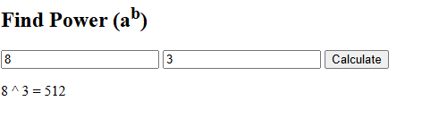

**Problem-07**

**Code:(HTML Code)**

<!DOCTYPE html>

<html lang="en">

<!-- Write a program to Create a Customized Table -->

<head>

<meta charset="UTF-8">

<meta name="viewport" content="width=device-width, initial-scale=1.0">

<title>Customized Table</title>

</head>

<body>

<!DOCTYPE html>

<html>

<head>

<title>Table</title>

</head>

<body>

<h2>Table</h2>

<table border="1" cellspacing="0" cellpadding="10">

<tr>

<td>r1c1</td>

<td>r1c3</td>

<td>r1c4</td>

<td colspan="2">r1c5</td>

</tr>

<tr>

<td>r3c1</td>

<td>r2c3</td>

<td colspan="2">r3c4</td>

<td>r3c6</td>

</tr>

<tr>

<td>r4c1</td>

<td colspan="2">r4c2</td>

<td>r4c4</td>

<td>r4c5</td>

</tr>

<tr>

<td>r5c1</td>

<td>r5c3</td>

<td colspan="2">r5c5</td>

<td>r6c4</td>

</tr>

</table>

</body>

</html>

</body>

</html>

**Output:**

